|  |  |
| --- | --- |
|  | **FPT ACADEMY INTERNATIONAL**  **FPT – APTECH COMPUTER EDUCATION** |

**Centre Name: ACE-HCMC-2-FPT.**

**Address: 590 Cach Mang Thang 8, District 3, Ho Chi Minh City, Viet Nam.**

**CAMBRIDGE HOSPITAL**

|  |  |  |
| --- | --- | --- |
| **Supervisor.** | Mr. Nguyen Phat Tai | |
| **Batch.** | T1.2106.E1 | |
| **Group.** | Group 1 | |
| **Serial No.** | **Enrollment Number** | **Student Name** |
| 1. | Student1319917 | Dao Bui Quang Hung |
| 2. | Student1318431 | Le Duc Gia Thinh |
| 3. | Student1317115 | Nguyen Ngoc Kim Ngan |

Month 09 Year 2021

**This is to certify that**

**Mr.:**

Dao Bui Quang Hung

Le Duc Gia Thinh

Nguyen Ngoc Kim Ngan

**has successfully designed & developed**

eProject: Cambridge Hospital

**Submitted by: Dao Bui Quang Hung**

**Date of issue: 11-Oct-2021**

**Authorized Signature: Hung**

**TABLE OF CONTENTS**

FPT – APTECH COMPUTER EDUCATION 1

ACKNOWLEGMENT 4

SYNOSIS 4

PROBLEM DEFINITION 4

CUSTOMER'S REQUIREMENTS SPECIFICATIONS (CRS) 5

Business/Project Objective: 5

Hardware/ Software Requirements: 6

SCOPE OF THE WORK (IN BRIEF) 7

Architecture and design of the system 8

Diagram of the website 9

TASK SHEET REVIEW 1 10

# ACKNOWLEGMENT

On behalf of all the members of group 1, I would like to acknowledge all those who have given moral support and helped me make the project a success.

I wish to express my gratitude to the eProjects Team at the Head Office, who guided and helped me. I also express my sincere gratitude to the eProjects Team at the Aptech Head Office and my project guide at the organization, for his valuable guidance and support for the completion of this project. Especially, Mr. Nguyen Phat Tai, our teacher, he has helped us a lot from the day he started teaching us. With this eProject, he has guided us with his enthusiasm and rigorous, because of his guiding, we would be able to finish this project. I would also like to express my gratitude to all the staff members of my center for not only providing me with the opportunity to work with them on this project, but also for their support and encouragement throughout the process.

And finally, I would like to offer many thanks to all the team member of group 1 for their valuable suggestions and constructive feedback, each of the team members has been working continuously in 4 weeks in order to complete this project. The last but not least, we would like to say thank you to our family for always supporting us, creating the best conditions for us to focus on the project, and putting faith in the dreams we pursue.

# SYNOSIS

Cambridge Hospital is one of the most famous hospital in the town since 1928, now the hospital organization wish to change their existing website completely. The website which they demand is suppose to provide user friendly environment and navigation. The important menu must be stated in the top section of the webpage. Also a decent look out and color combination is expected.

The website is to be developed for the Windows Platform using HTML5, JavaScript and Geolocation. The site should work well in all leading browsers including Chrome, IE, Firefox etc.

# PROBLEM DEFINITION

The Web site is to be created based on the following requirements.

1. The Home Page with some description about the Cambridge Hospital like who is the founder and some of the achievements of handling critical cases.(Also navigational link must be included.)
2. The website must provide information like “About us”, “Department”, “Facility”, “Services”, “Centres”, “Academic”, “Contact Us”, “Vacancies”, ”Query”, “Feedback”, “Success Stories”.
3. Each section must provide brief information.
4. Also each link must be properly hyperlinked, images must be used wherever necessary.
5. Contact Us page must flash the address of all the location where the hospital is located. Address of the hospital should be displayed using GeoLocation API (eg. GoogleMaps).
6. Department details like *“helpdesk”, “registration”, “Doctor Schedule”, Billing and Accounts”* and so on must be included.
7. Facility like *“rooms”, “ICU”, “Medical Facility”, “Other Facility”.*
8. Services like *“general services”, “Health Checkup”, “Specialties”* and so on.
9. Centres like *“diagnostic centre”, “cancer centre”, “heart centre”, “community health centre”.*
10. Feedback must be taken.
11. Query must be allowed to enter.

# CUSTOMER'S REQUIREMENTS SPECIFICATIONS (CRS)

**Client: CAMBRIDGE HOSPITAL**

### Business/Project Objective:

The Objective of this program is to give a sample project to work on real life projects. These applications help you build a larger more robust application.

The objective is not to teach you JavaScript/Dreamweaver but to provide you with a real life scenario and help you create basic applications using the tools.

You can revise the chapters before you start with the project.

This project is meant for students who have completed the module of ***HTML5***. These programs should be done in the Lab sessions with assistance of the faculty if required.

It is very essential that a student has a clear understanding of the subject. Students should go through the project and solve the assignments as per requirements given.

Kindly get back to @ [eproject@aptech.ac.in](mailto:eproject@aptech.ac.in) in case of any doubts regarding the application or its objectives.

**Input to the system:**

* + - * Browsing services based on brands, type of hospital services.

**Output from the system:**

* A menu that will categorize all the functions of the site.
* Display the list of available albums category wisely.
* Perform the search based on a particular: brands, type of hospital services.
* Site should be able to provide brief introduction/history about the hospital under About Us page.
* The location of the hospital under Contact Us page.
* Besides the above requirements, the site should have look and feel as per the industry standards.

**Expected delivery date:** 11-Oct-2021.

**List of deliverables:**

* + - * Document Word.
      * User Guide.
      * Source code.

### 

### Hardware/ Software Requirements:

* **For developer**

**Hardware**

* + A minimum computer system that will help you access all the tools in the courses is a Pentium 166 or better
  + 64 Megabytes of RAM or better

**Software**

* + Notepad/HTML editor
  + Dreamweaver
  + IE 5.0/ Netscape 6.0
* **For web users**

**Hardware**

* + Intel Pentium 4 processor or higher
  + 512 Megabytes of RAM or higher

**Software**

* + Windows XP OS or higher
  + Web browsers such as IE, Chrome or Firefox are supporting HTML5, CSS3 and Javascript.

# SCOPE OF THE WORK (IN BRIEF)

After a long and detailed discussion, our group has decided to create a website contain the following webpages:

1. ***Homepage*:** Display information about the founder and some of the achievements of handling critical cases. (Also navigational link must be included.)
2. **Departments:** Display all department: helpdesk, registration, Doctor Schedule, Billing and Accounts.
3. **Facilities:** Display the information of rooms, ICU, Medical Facility, Other Facility.
4. ***Services*:** Display the information of service: general services, Health Checkup, Specialties.
5. **Centres:** Display the information aboutdiagnostic centre, cancer centre, heart centre, community health centre.
6. ***About Us*:** Display the information about the hospital and about us (including **Academic** information).
7. ***Contact***: Display the address of the hospital, allowing patients to **query** any information they want from Hospital.
8. **Success Stories:** Patients’ stories.
9. **Vacancies:** Display hiring information.

# Architecture and design of the system

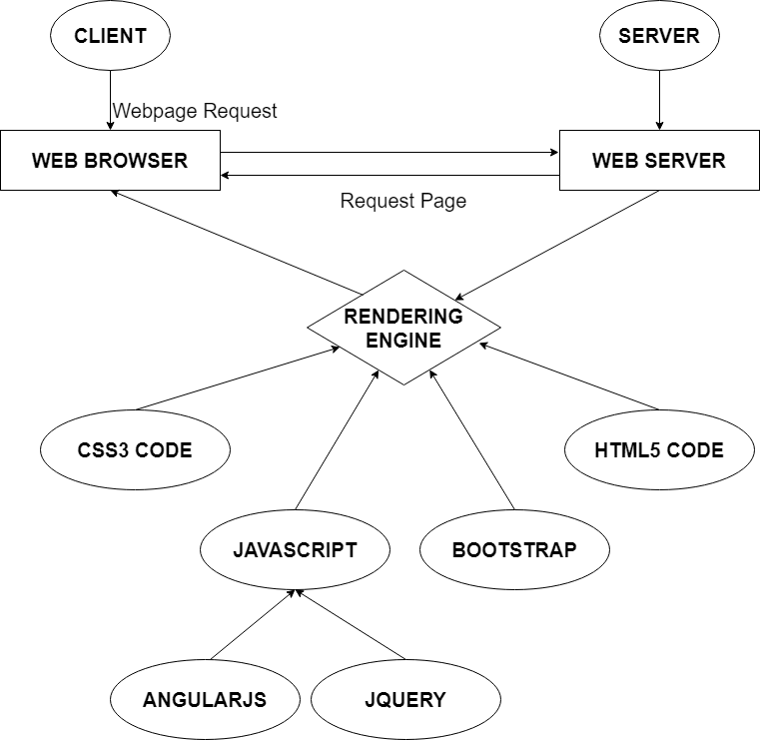

# Diagram of the website

HOME

ABOUT US

VACANCIES

.

DEPARTMENTS

FEATURES

CONTACT US



# TASK SHEET REVIEW 1

|  |  |  |  |  |  |  |  |
| --- | --- | --- | --- | --- | --- | --- | --- |
| **Project Ref. No.:**  **eP/Advertisement Portal Management**  **System/01** | | **Project Title:** | **Activity Plan Prepared By:** | **Date of Preparation of Activity Plan:** | | | |
| **Sr.**  **No.** | **Task** | **Actual**  **Start Date** | **Actual Days** | **Team**  **Mate Names** | **Status** |
| 1 | Problem Statement | Cambridge  Hospital | Hung | 11-Sep-2021 | 1 | Ngan | Completed |
| 2 | Analysis of Cambridge Hospital’s requirements about the website | 11-Sep-2021 | 1 | Hung | Completed |
| 3 | The scope of the work (in brief) | 11-Sep-2021 | 1 | Ngan | Completed |
| 4 | Architecture and design of the system | 11-Sep-2021 | 1 | Thinh | Completed |
| 5 | Diagram of the website | 11-Sep-2021 | 1 | Ngan | Completed |
| 6 | Task Sheet | 11-Sep-2021 | 1 | Ngan | Completed |

|  |  |
| --- | --- |
| **Date:** | |
| Signature of Instructor:  **Mr. Nguyen Phat Tai** | Signature of Team Leader:  **Mr. Dao Bui Quang Hung** |

# SITE MAP

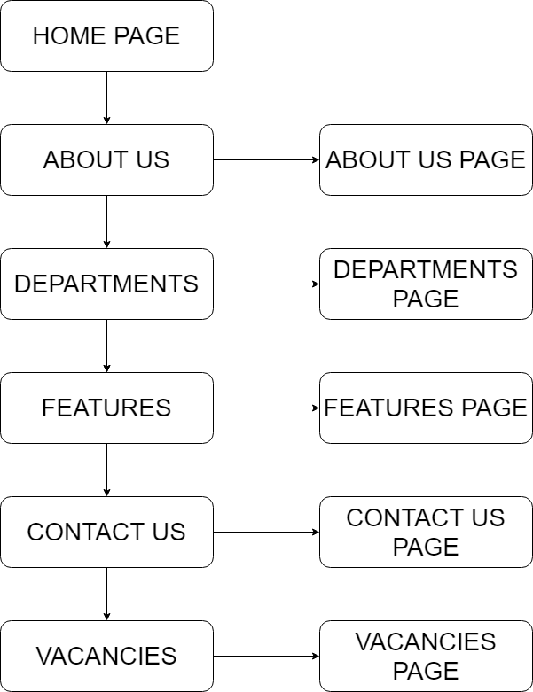

# MOCK OF THE WEBSITE

**1. Home Page**

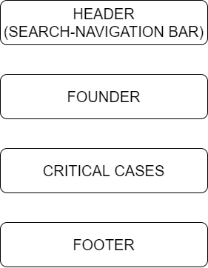

**2. About Us**

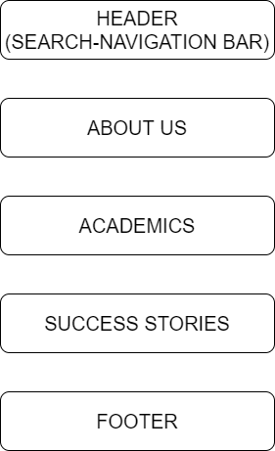

**3. Departments**

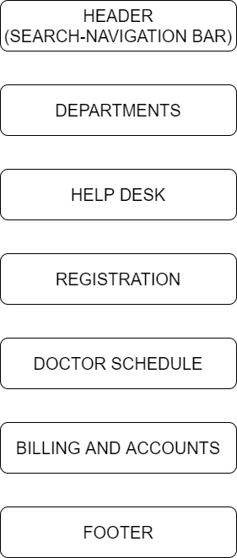

**4. Features**

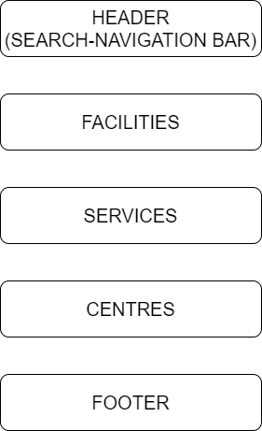

**5. Contact Us**

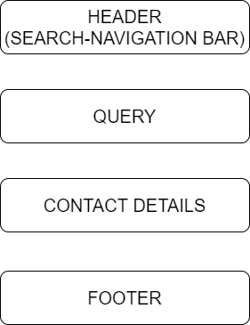

**6. Vacancies**

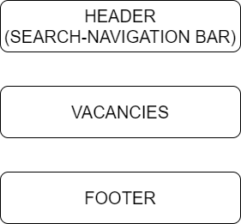

# TASK SHEET REVIEW 2

|  |  |  |  |  |  |  |  |
| --- | --- | --- | --- | --- | --- | --- | --- |
| **Project Ref. No.:**  **eP/Advertisement**  **Portal Management System/01** | | **Project Title:** | **Activity Plan Prepared By:** | **Date of Preparation of Activity Plan:** | | | |
| **Sr.**  **No.** | **Task** | **Actual Start Date** | **Actual Days** | **Team Mate Names** | **Status** |
| 1 | Site map | Cambridge Hospital | Hung | 21-Sep-21 | 1 | Thinh | Completed |
| 2 | Mock of the website | 21-Sep-21 | 1 | Hung | Completed |
| 3 | Task sheet | 21-Sep-21 | 1 | Ngan | Completed |

|  |  |
| --- | --- |
| **Date:** | |
| Signature of Instructor:  **Mr. Nguyen Phat Tai** | Signature of Team Leader:  **Mr. Dao Bui Quang Hung** |

# WEBSITE DESCRIPTION

1. **Home Page**

* Description

Home page displays following information:

* Description about the Cambridge Hospital.
* Information about the founder.
* Achievements of handling critical cases.
* Screenshot

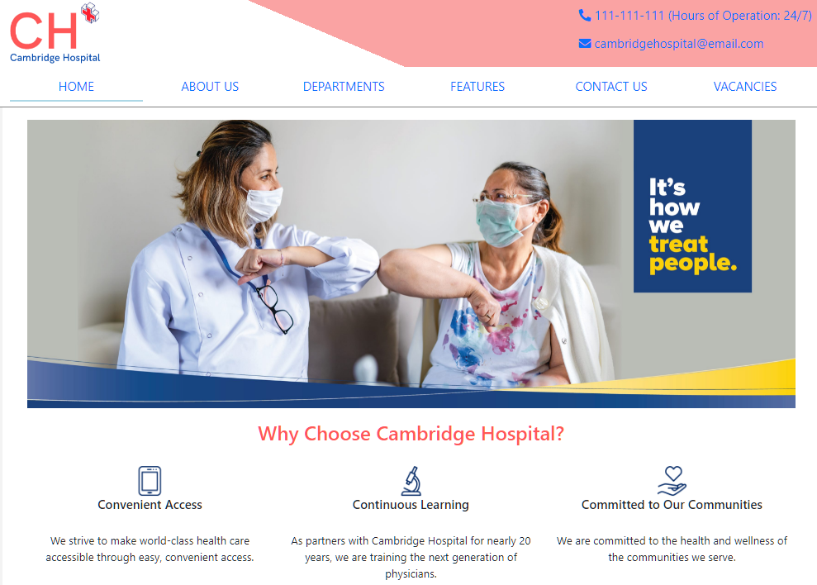

Information about the founder

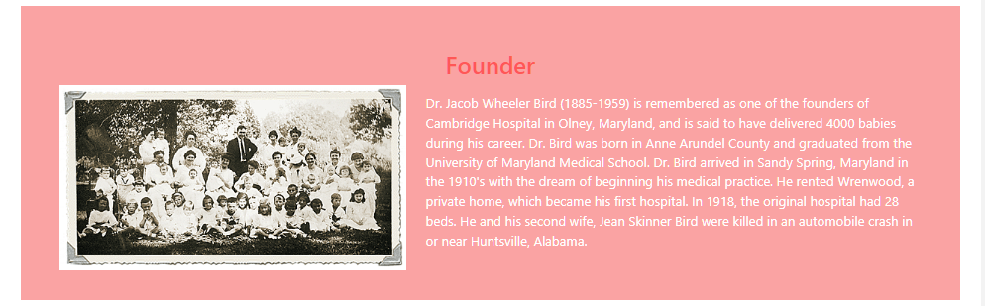

Achievements of handling critical cases

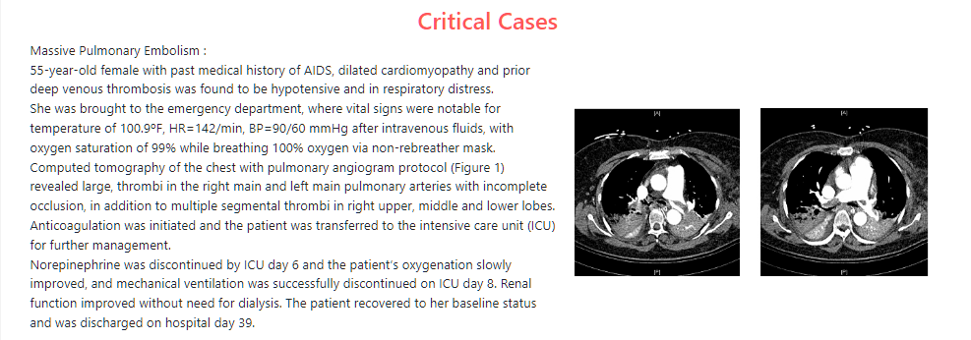

Footer

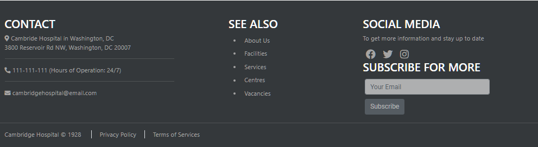

Feedback (on the side)

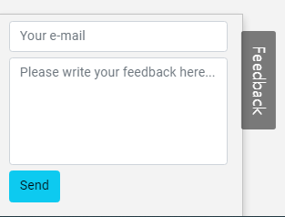

1. **About us**

* Description
* This page displays information about Cambridge Hospital.
* Display academics
* Display success stories
* Screen shot

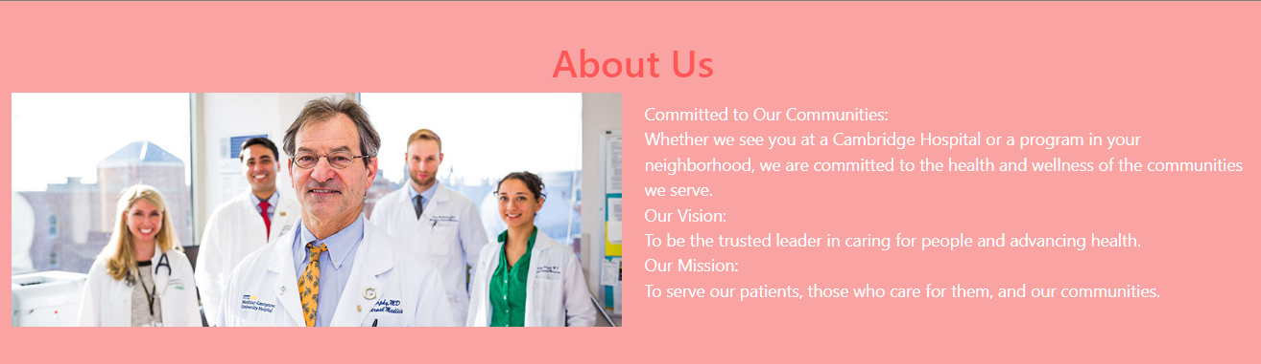

Academics

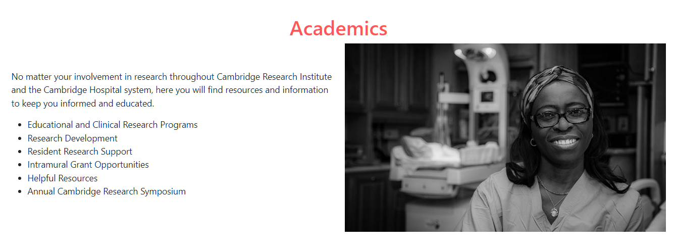

Success Stories

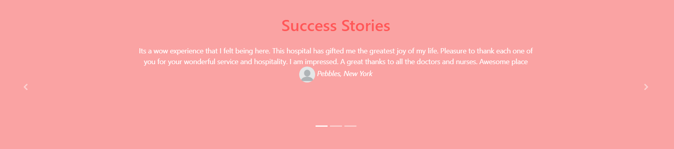

1. **Departments:**

* Description

This page displays a list of departments that, when clicked, will redirect to pages containing information about each department, along with helpdesk, registration, doctor schedule, and billing and accounts.

* Screen shot

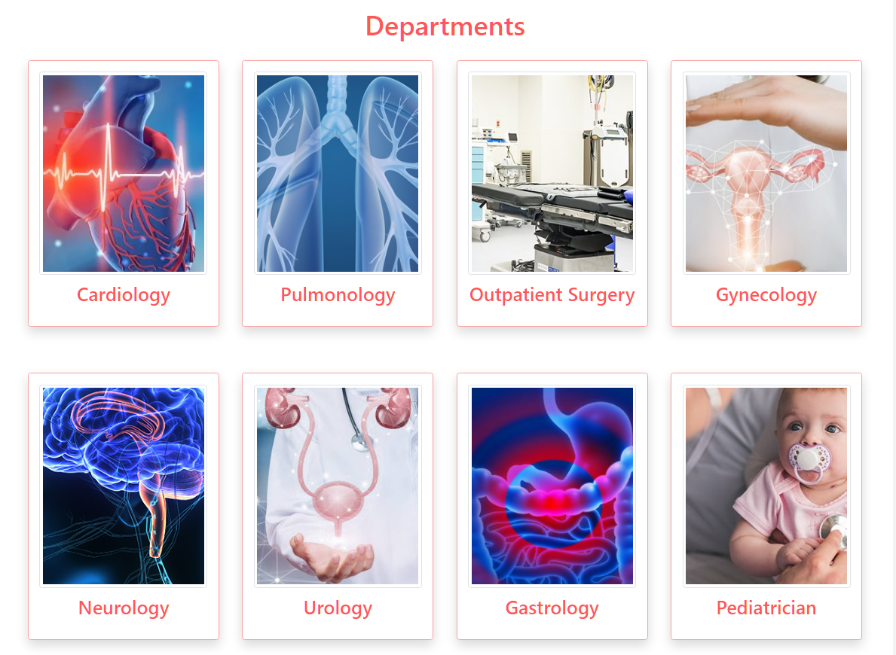

Department page example

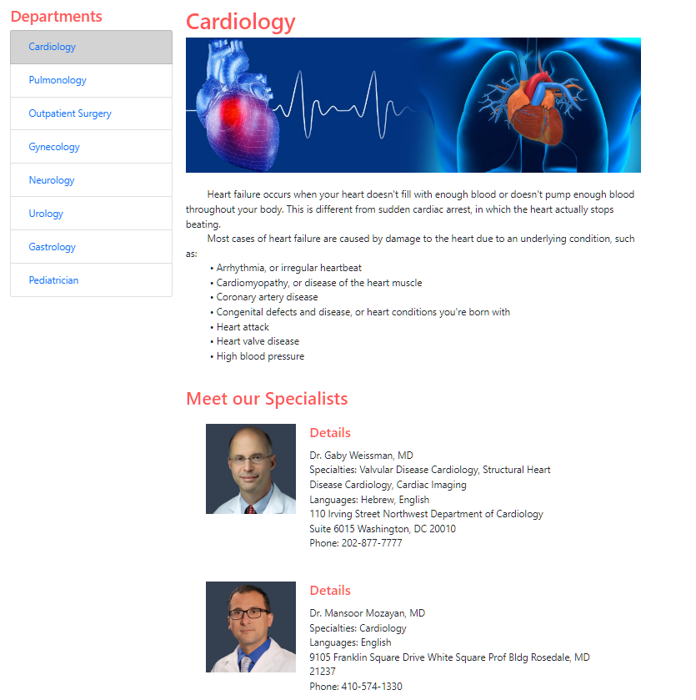

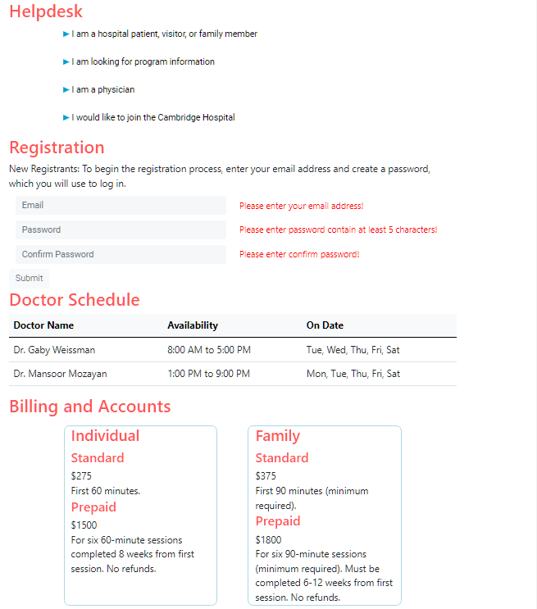

1. **Features:**

* Description:
* This page displays three features which are facilities, services, centres. When clicked, will redirect to the corresponding pages.
* Screen shot

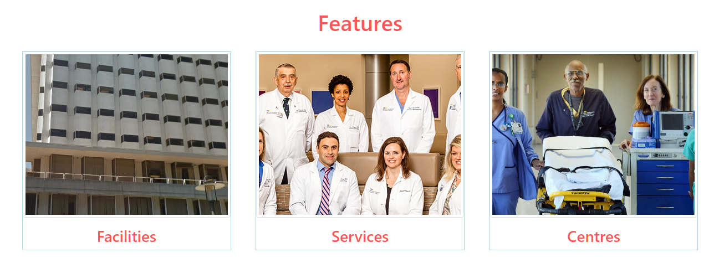

Facilities

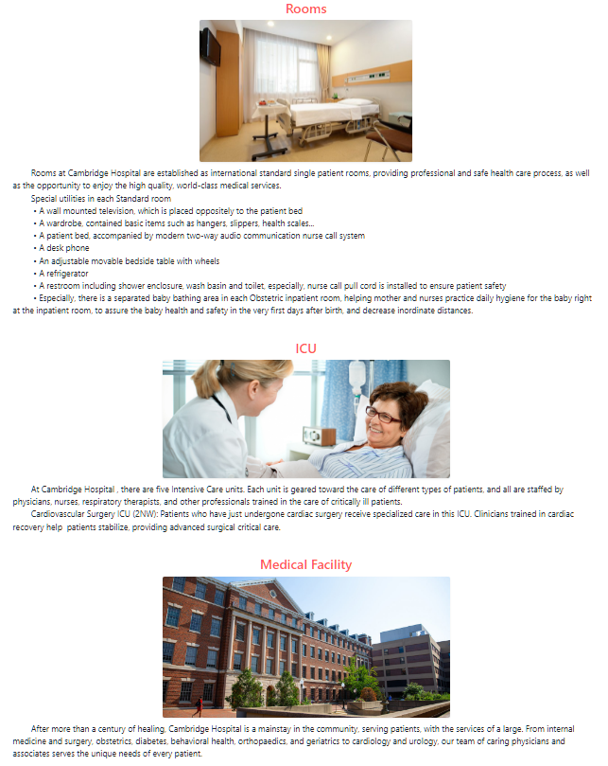

Services



Centres

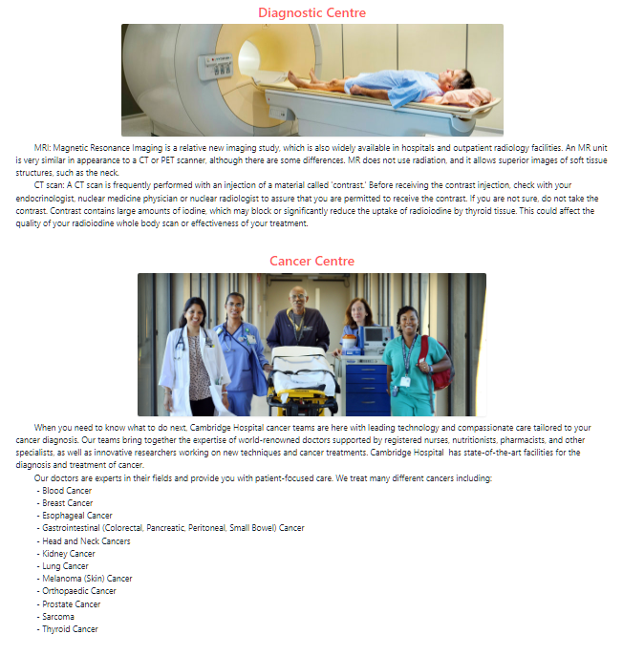

1. **Contact Us:**

* Description:

This page displays following information:

Query section

Contact details

GeoLocation API

* Screen shot

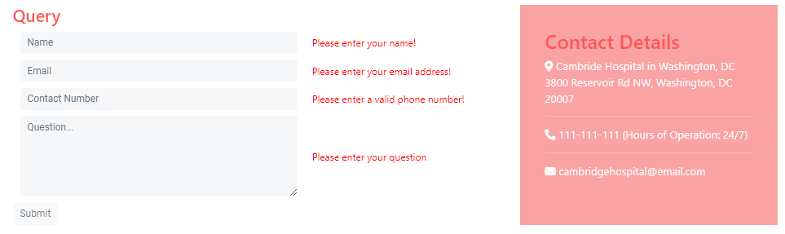

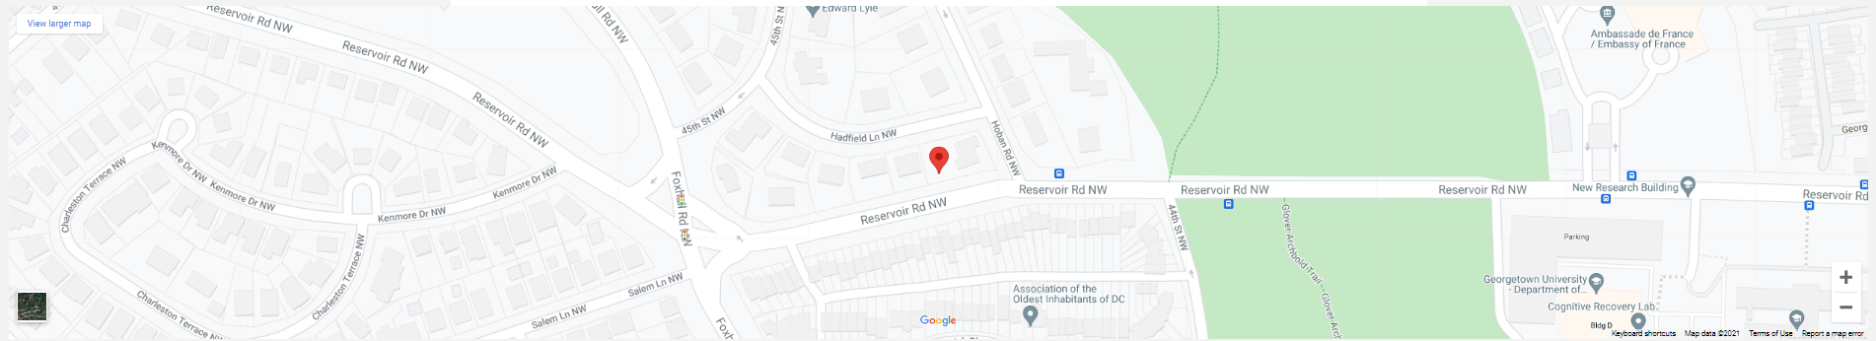

1. **Vacancies:**

* Description:

This page displays following information:

Hiring details

Application form

* Screen shot

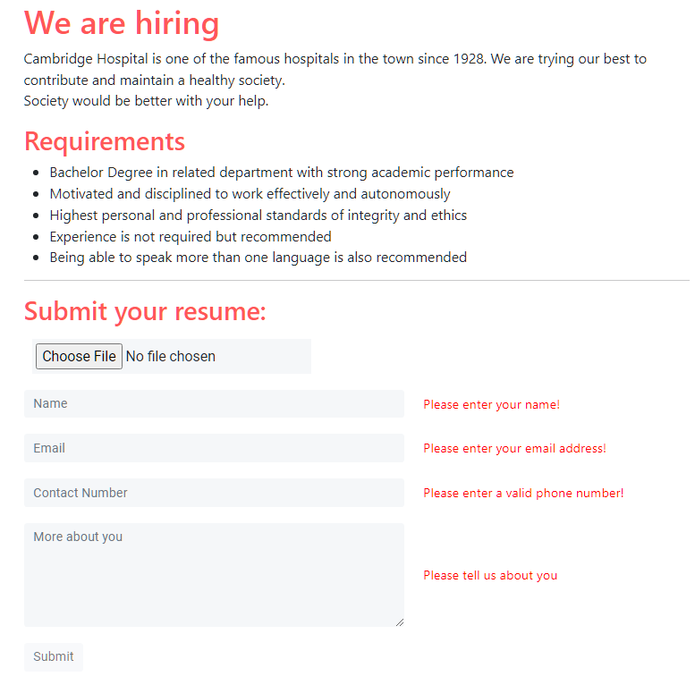

**HTML, CSS, JAVASCRIPT DESCRIPTION**

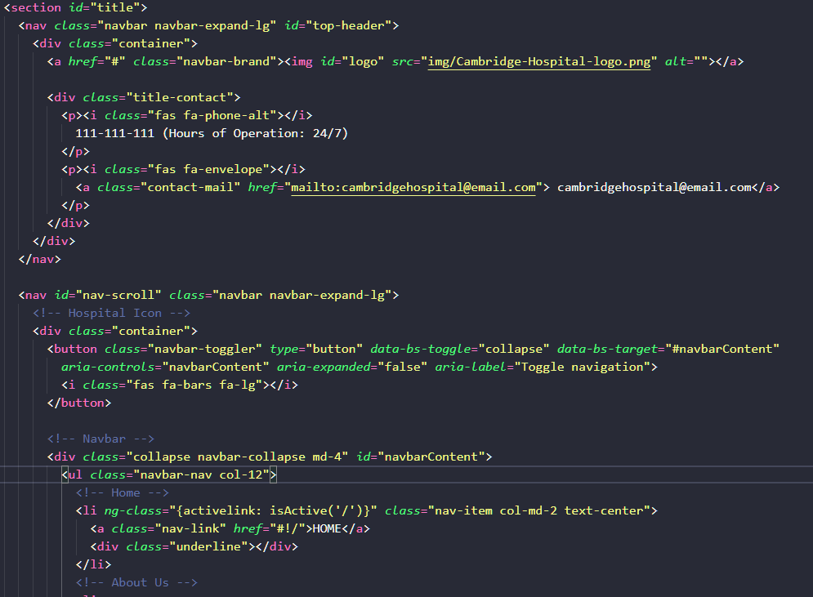

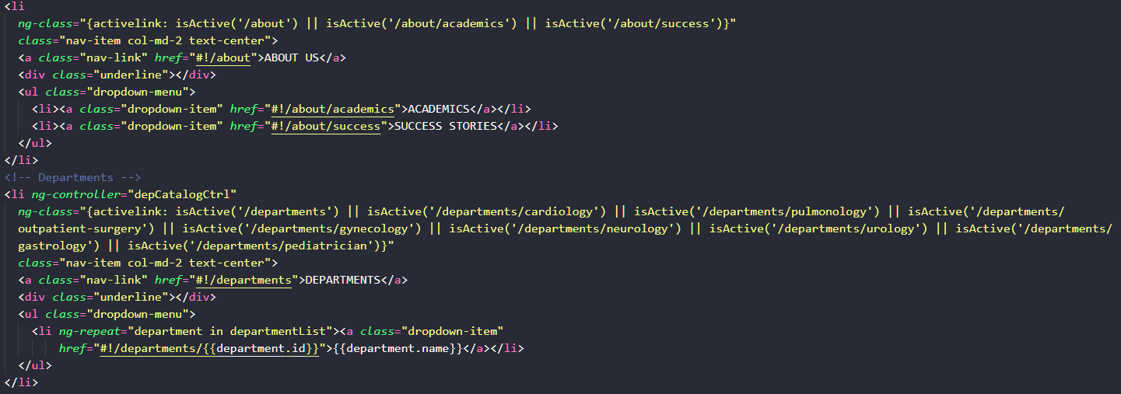

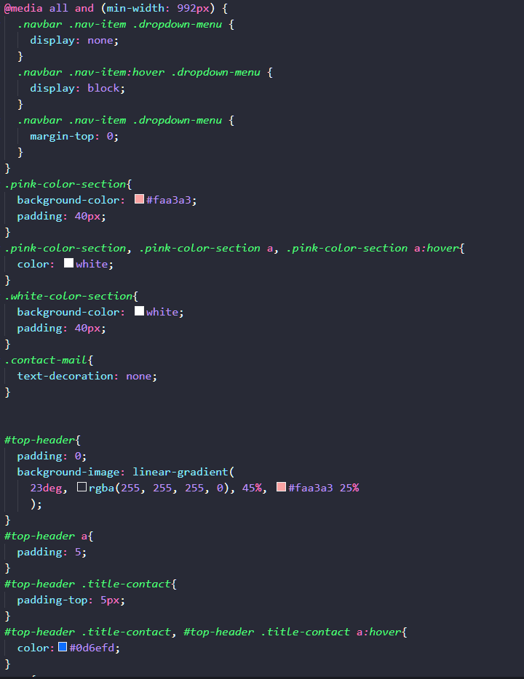

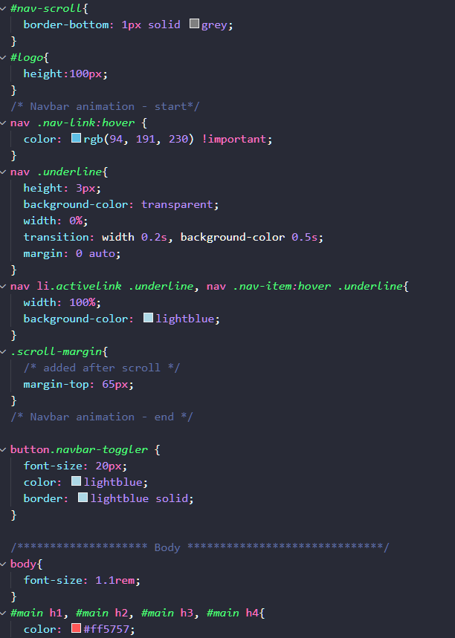

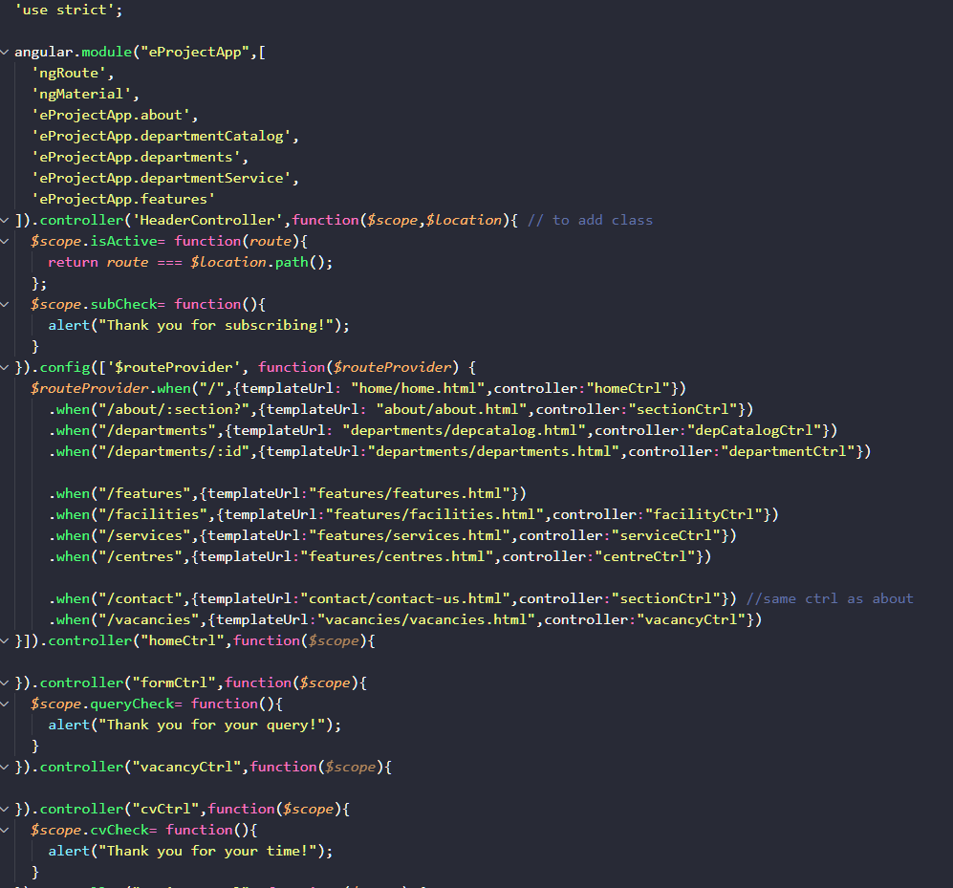

# TASK SHEET REVIEW 3

|  |  |  |  |  |  |  |  |
| --- | --- | --- | --- | --- | --- | --- | --- |
| **Project Ref. No.:**  **eP/Advertisement Portal Management System/01** | | **Project Title:** | **Activity Plan Prepared By:** | **Date of Preparation of Activity Plan:** | | | |
| **Sr.**  **No.** | **Task** | **Actual Start**  **Date** | **Actual Days** | **Team Mate**  **Names** | **Status** |
| 1 | Home | **Cambridge Hospital** | **Hung** | 26-Sep-21 | 2 | Ngan | Completed |
| 2 | About Us | 27-Sep-21 | 2 | Ngan | Completed |
| 3 | Departments | 26-Sep-21 | 3 | Ngan | Completed |
| 4 | Features | 28-Sep-21 | 2 | Hung | Completed |
| 5 | Contact Us | 29-Sep-21 | 1 | Thinh | Completed |
| 6 | Vacancies |  |  | 26-Sep-21 | 1 | Hung | Completed |

|  |  |
| --- | --- |
| **Date: 8/10/2021** | |
| Signature of Instructor:  **Mr. Nguyen Phat Tai** | Signature of Team Leader:  **Mr. Dao Bui Quang Hung** |